NelNet Multi-Factor Authentication
If you need assistance navigating this process, please email paymentplan@howardcc.edu.

- Under Make a Payment, select Proceed to Processor.
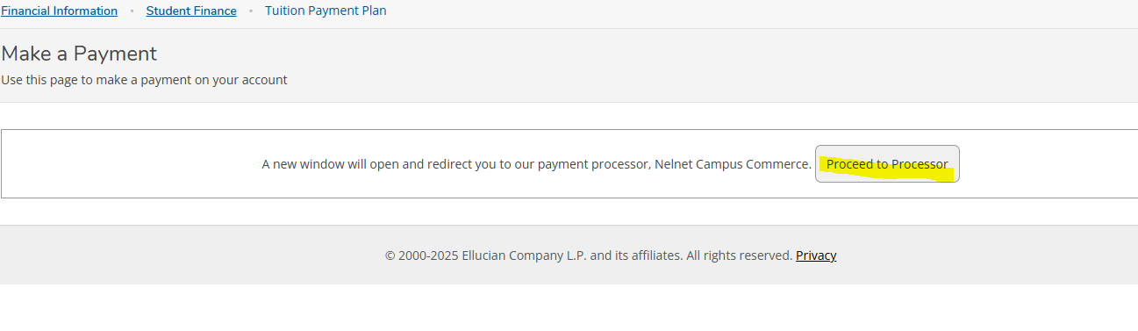
- Select either Use Email or Use Authenticator App.
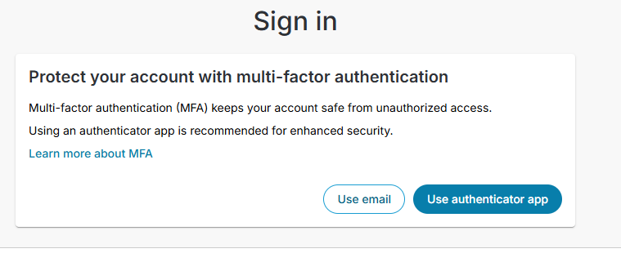

- If you selected Use Email, choose an email from the choices provided.

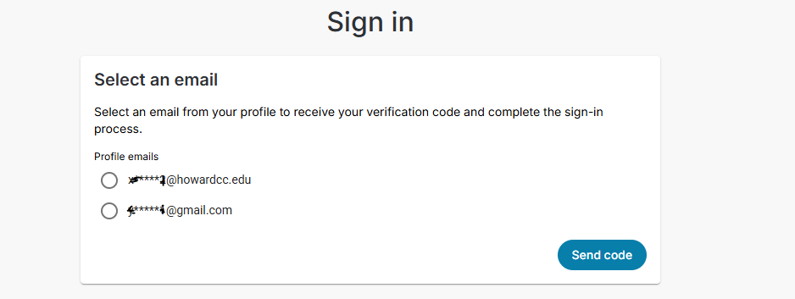

- If you selected Use Authenticator App, follow the instructions.
